The KPI’s

1.Total revenue

Query- select sum(total_price) as Total_revenue from pizza_sales

Result:

2. Total order’s

Query - select count(distinct order_id) as total_orders from pizza_sales

Result: 

3. Average order value

Query- select SUM(total_price)/COUNT(distinct order_id) as Average_order_value from pizza_sales

Result: 

4. Total pizza sold

Query - select sum(quantity) as Total_pizza_sold from pizza_sales

Result : 

5. Average pizza per order

Query- select cast(cast(sum(quantity) as decimal(7,2))/cast(count(distinct order_id) as decimal(7,2)) as decimal(7,2)) as Average_pizza_per_order from pizza_sales

Result: 

6. Total Order by quantity per day of week per year

Query – select DATENAME(DW, order_date) as order_day, count(distinct order_id) as total_quantity from pizza_sales group by DATENAME(DW, order_date)

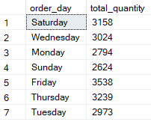

Result -

7. Total order/sale/quantity per month for a year

Query - select Datename(month,order_date) as Order_month , count(distinct order_id) as total_quantitiy,cast(sum(total_price) as decimal(7,2)) as total_sales ,

sum(quantity) as total_quantity from pizza_sales group by Datename(month,order_date)

Result - 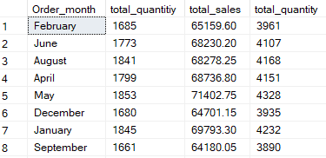

8. Top 5 Pizza’s by revenue

Query – SELECT top 5 pizza_name , count(distinct order_id) as total_order , sum(total_price) as total_sales ,sum(quantity) as

total_quantity from pizza_sales group by pizza_name order by total_sales desc

Result - 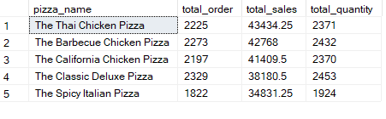

9. Worst 5 pizza’s by revenue

Query - SELECT top 5 pizza_name , count(distinct order_id) as total_order , sum(total_price) as total_sales ,sum(quantity) as

total_quantity from pizza_sales group by pizza_name order by total_sales

Result – 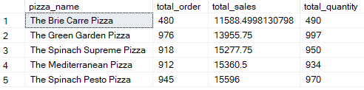

10. Top 5 pizza’s by quantity

Query - SELECT top 5 pizza_name , count(distinct order_id) as total_order , sum(total_price) as total_sales ,sum(quantity) as

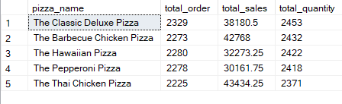total_quantity from pizza_sales group by pizza_name order by total_quantity desc

Result –

11. Worst 5 pizza’s by quantity

Query - SELECT top 5 pizza_name , count(distinct order_id) as total_order , sum(total_price) as total_sales ,sum(quantity) as

total_quantity from pizza_sales group by pizza_name order by total_quantity

Result - 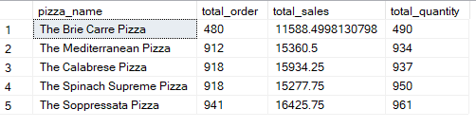

11. Top 5 pizza’s by order

Query – SELECT top 5 pizza_name , count(distinct order_id) as total_order , sum(total_price) as total_sales ,sum(quantity) as

total_quantity from pizza_sales group by pizza_name order by total_order desc

Result - 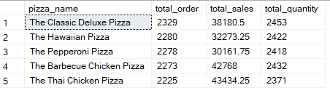

11. Worst 5 pizza’s by order

Query - SELECT top 5 pizza_name , count(distinct order_id) as total_order , sum(total_price) as total_sales ,sum(quantity) as

total_quantity from pizza_sales group by pizza_name order by total_order

Result - 